POWR QUERY – COMBINING DATA FROM MULTIPLE WORKBOOKS

Sales Data for 2016, 2017 and 2018. Containing information on Date, Item, Quantity and Price.

I have opened a new Excel file and named it Combined Sales Data. This file is empty. I will combine all sales data into one file, using Power Query.

I am using Excel 2019; Power Query is built in and not a separate add-in. It is located in the Data tab in the Get & Transform section. In Excel 2016 if you have not used Power Query before. It will have to be activated via File/Options/Add-Ins.

1. From the Combined Sales Data file. Go to the Data tab, under Get & Transform section. Get Data/ From File/From Folder. Locate the sales data folder.

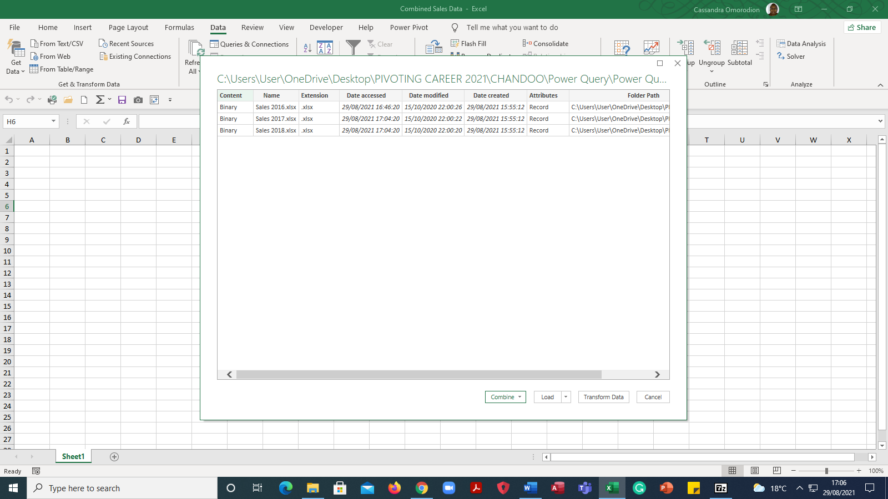

Click Transform Data (Excel 2019 or edit in older versions of Excel)

1. Sales Data -Power Query Editor will open. On the right within the Content Column, click double arrows. To show Power Query

an example of the file to be combined. 

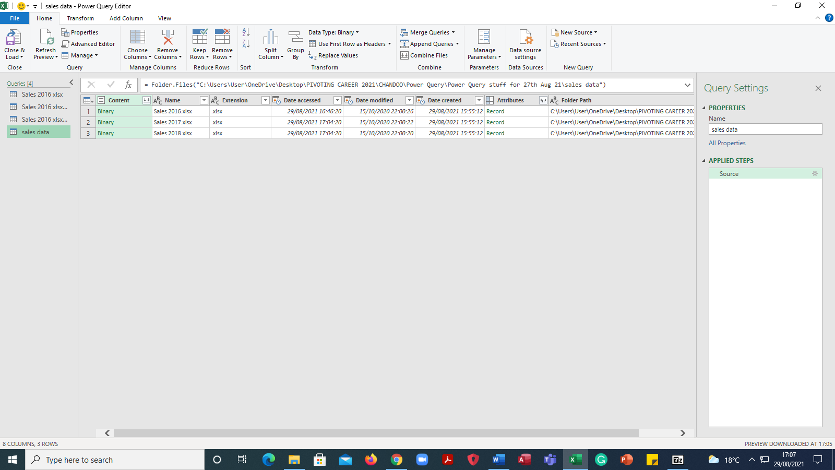

Click Sheet1 

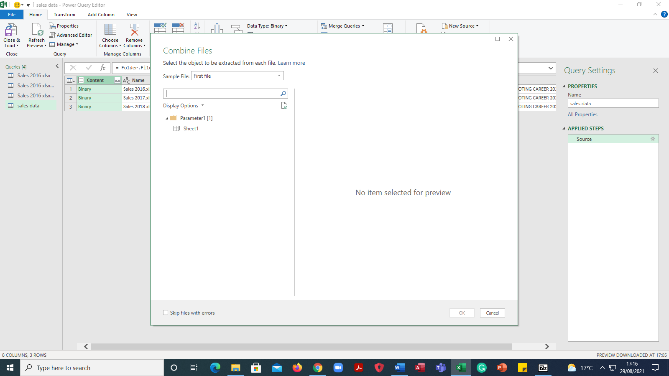

1. The data is revealed below in the Preview Box

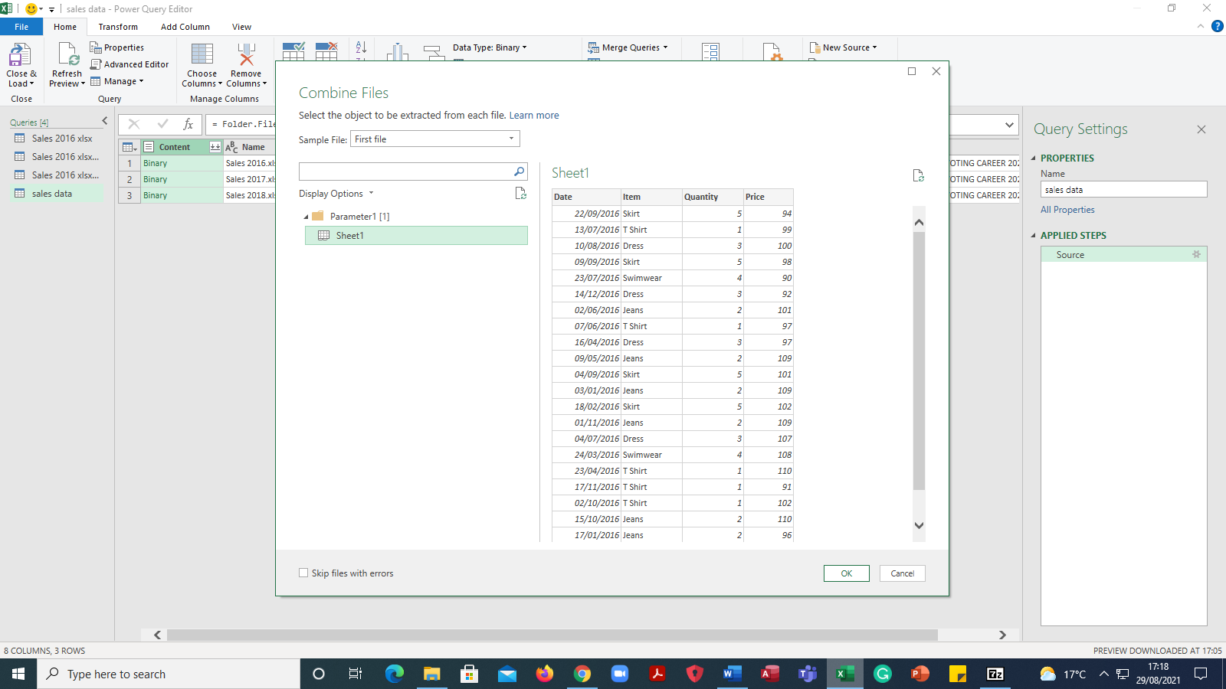

Click Ok

1. All three files 2016,2017,2018 are now combined with Power Query Editor

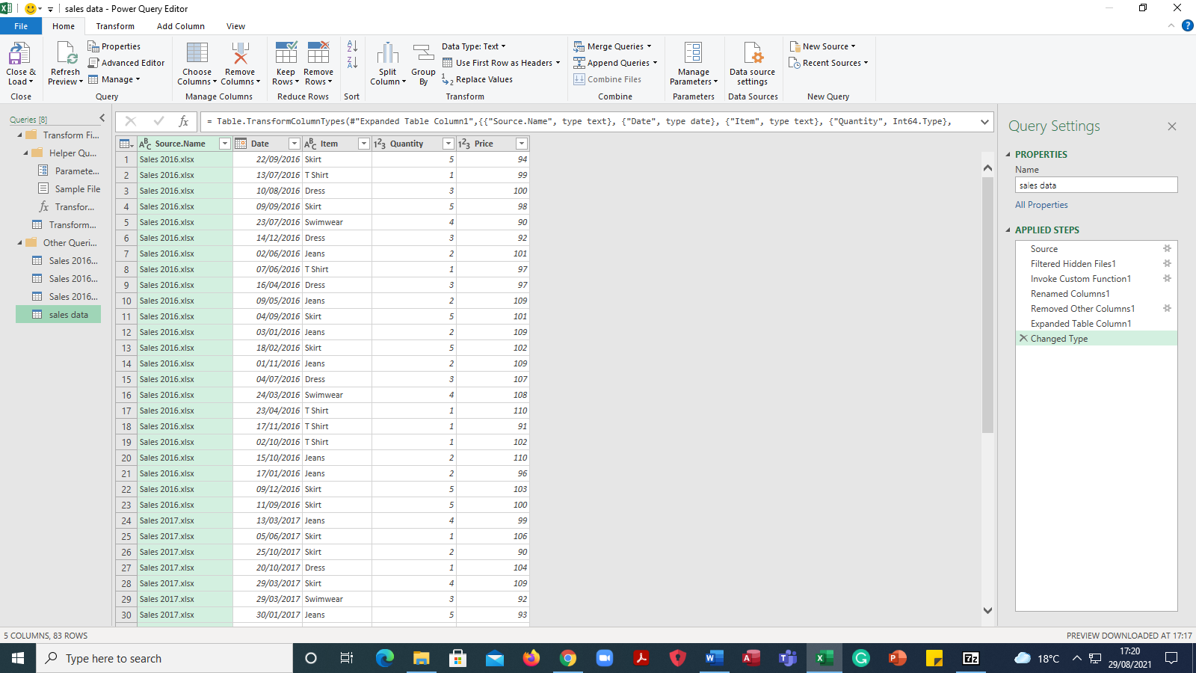

Move the Scroll Bar on the left and look at the data on the right. All three files containing sales for 2016, 2017 and 2018 have now been loaded onto Power Query Editor.

Close & Load. The data can now be viewed within the Excel Workbook.

The Source Name Column contains the name of the file from which the data was imported.

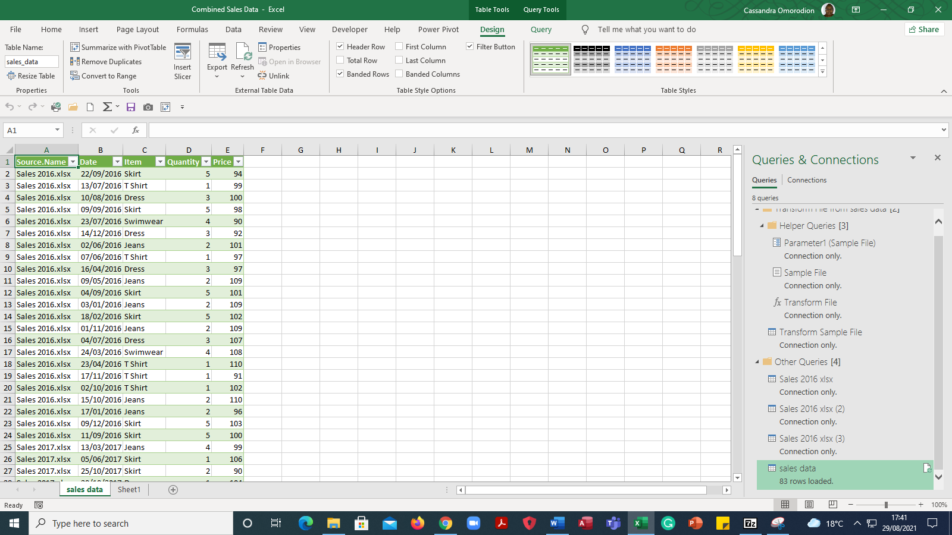

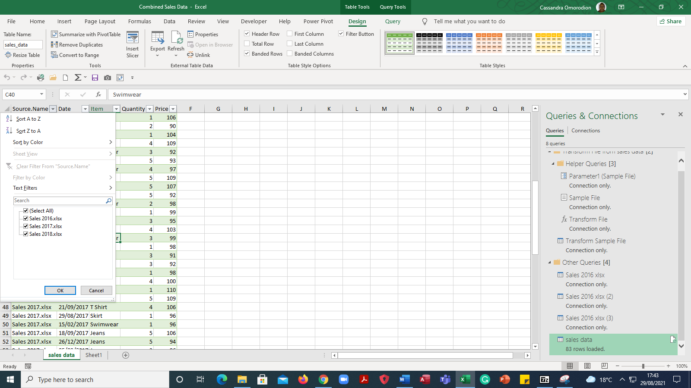

To update the combined sales data file with sales data for 2019. Move Sales Data 2019 to the same folder as the previous ones. Go to the Data tab in the Combined Sales Data file and Refresh All. 2019 data will appear.

Combined Sales Data file with additional Sales Data for 2019

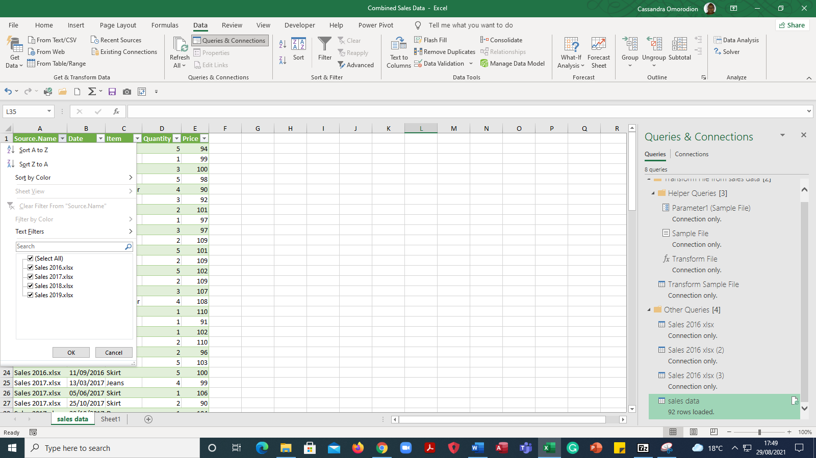

END.